OVERALL PROGRAMME EVALUATION REPORT
Social Entrepreneurship Program (SEP)- START Alumni MASTERCLASS (16th February 2026 - 20th February 2026)
No. of Respondents: 14
No. of Participants: 102
Response Rate: 14%
--------------------------------------------------

Faculty Reports

Felix Arthur Okoboi - Long-term sustainability planning
Evaluation Parameter | (%) Individual Score | (%) Programme Average
Punctuality (Commencement and Completion of Sessions) | 93 | 80
How well do you understand the core concepts presented? | 86 | 80
Rate your confidence in applying the new skills learnt | 83 | 74
Degree of Faculty preparedness for the sessions | 93 | 92
Content and methodology of the program | 91 | 87
Quality of class and group discussions | 86 | 74
The information presented in the course is relevant to my work (ministry) | 90 | 88
Average scores | 89 | 82

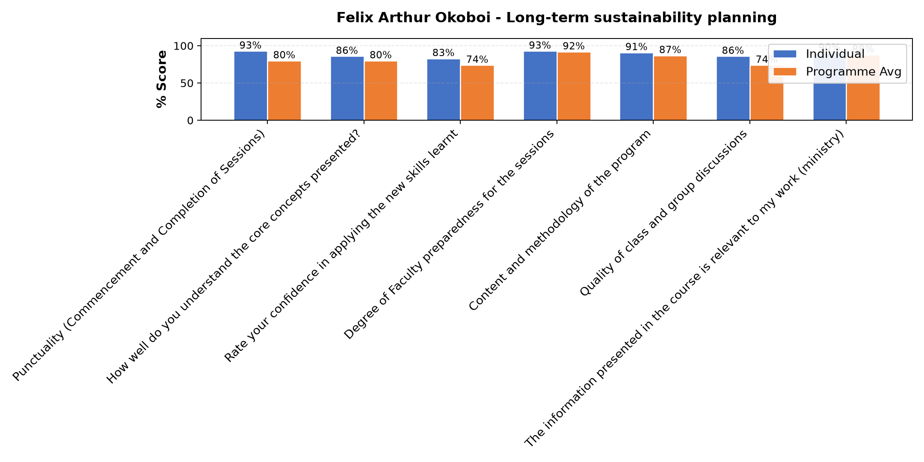

Comments & Feedback
- • Change of ministry ministry
- • In adquate funds
- • Transfers within a short time
- • Distance from the project site
- • the new ministry assigned.
- • Un planned transfer and not working within the field of an enterprise
- • Keeping records to me is a challenge and yet this is important
- • Fluctuation of prices
- • Limited capital
- • Abrupt Transfer to another community
- • My attendance was partial due to network problems. but i will apply the little i got.

Dr. James Onyoin - Review (identify gaps/challenges) your business plan from module/ Decide key issues for long-term sustainability/ Identify areas where support is needed
Evaluation Parameter | (%) Individual Score | (%) Programme Average
Punctuality (Commencement and Completion of Sessions) | 65 | 80
How well do you understand the core concepts presented? | 85 | 80
Rate your confidence in applying the new skills learnt | 75 | 74
Degree of Faculty preparedness for the sessions | 95 | 92
Content and methodology of the program | 90 | 87
Quality of class and group discussions | 70 | 74
The information presented in the course is relevant to my work (ministry) | 90 | 88
Average scores | 81 | 82

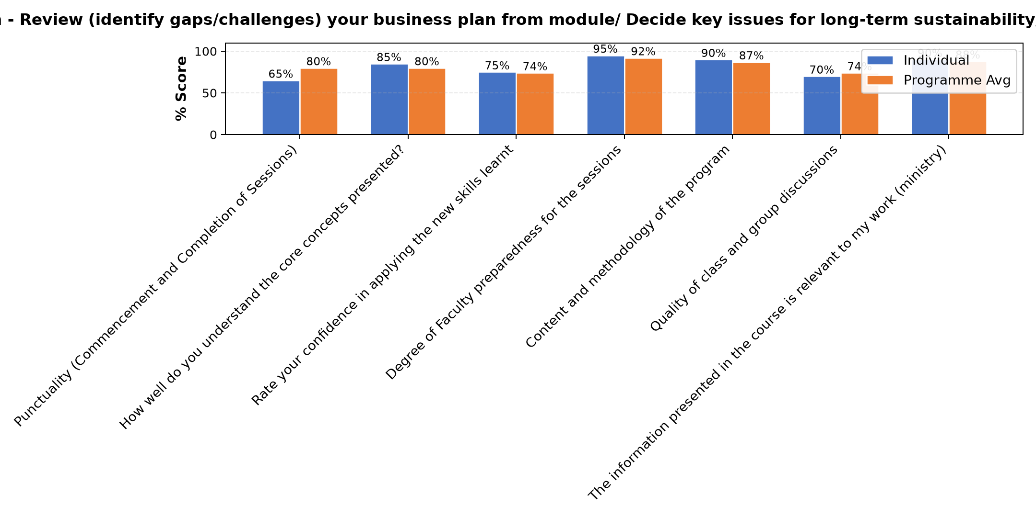

Comments & Feedback
- • Learning will be applied.
- • Distance from the project site
- • Thanks for all support offered.
- • It was good having this follow up session
- • I liked the presentation because it was a way of screening and assessing the work we are doing, what we have missed out, what do we have to apply and how do we do it. Thanks to Dr. James, it was empowering presentation

Dr. Tom Buringuriza - Review current funding of social enterprise / Identify Funding Gap/ Preparing funding plan
Evaluation Parameter | (%) Individual Score | (%) Programme Average
Punctuality (Commencement and Completion of Sessions) | 83 | 80
How well do you understand the core concepts presented? | 71 | 80
Rate your confidence in applying the new skills learnt | 69 | 74
Degree of Faculty preparedness for the sessions | 91 | 92
Content and methodology of the program | 83 | 87
Quality of class and group discussions | 71 | 74
The information presented in the course is relevant to my work (ministry) | 84 | 88
Average scores | 79 | 82

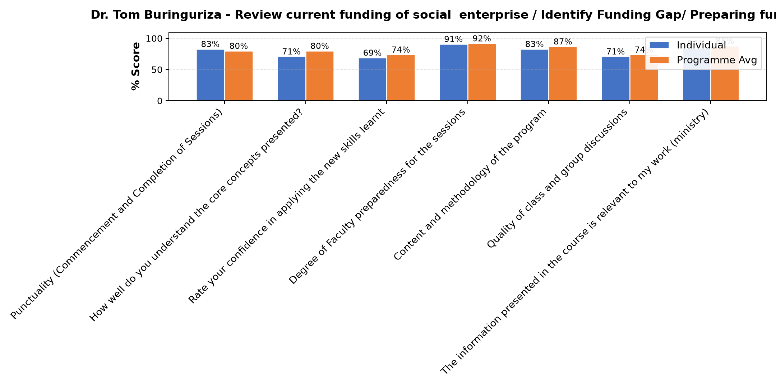

Comments & Feedback
- • Identifying a finding gap remains a challenge.
- • Lack of some skills
- • Distance from the project site
- • Lack of proper planning and resources.
- • Lack of resources

Dr. Cathy Mbidde - Social impact measures and planning
Evaluation Parameter | (%) Individual Score | (%) Programme Average
Punctuality (Commencement and Completion of Sessions) | 80 | 80
How well do you understand the core concepts presented? | 77 | 80
Rate your confidence in applying the new skills learnt | 71 | 74
Degree of Faculty preparedness for the sessions | 87 | 92
Content and methodology of the program | 83 | 87
Quality of class and group discussions | 69 | 74
The information presented in the course is relevant to my work (ministry) | 86 | 88
Average scores | 79 | 82

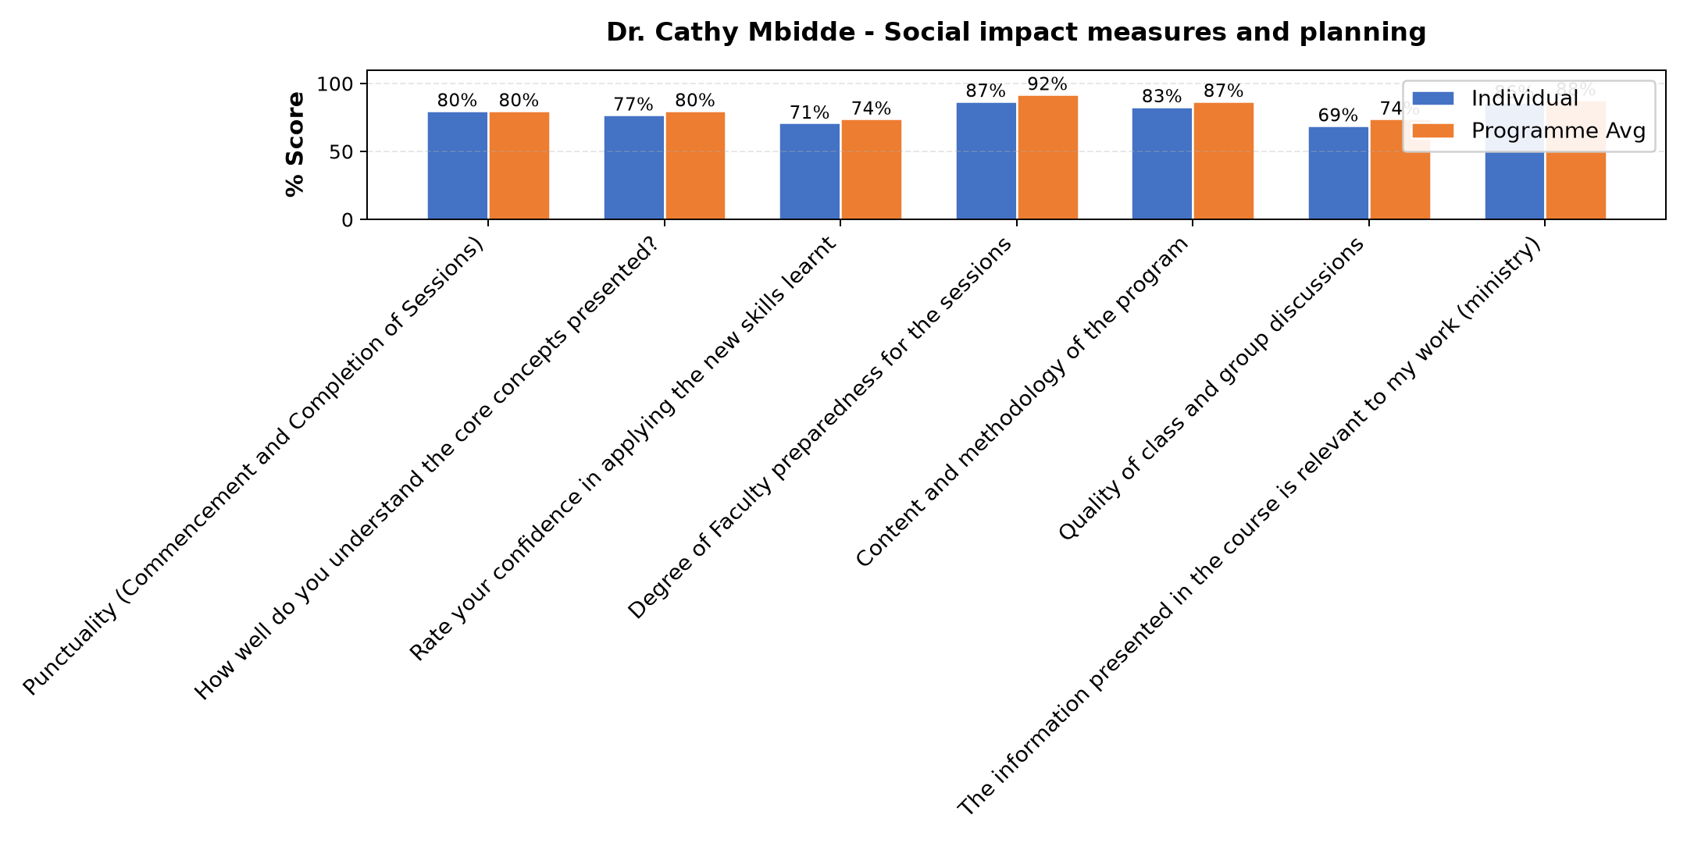

Comments & Feedback
- • Time limitation
- • Scarcity of resources
- • Distance from the project site
- • Lack of enough resources
- • ministry at hand. time clashes.
- • financial constraint

Department Reports

Are there any other comments and/or suggestions that you may want to add?

Comments & Feedback
- • Kindly talk to our superiors to at least leave one member who attended the course ind that specific enterprise to ease the monitoring work
- • I am very grateful to Strathmore University for giving us opportunities to attend this program. I also appreciate the facitators who ensured that we get the information we needed.
- • Do not get tired with us

Program Manager (Matilda Biira)
Evaluation Parameter | (%) Score
Punctuality in sending materials and programme information | 97
Communication skills(verbal and written) | 94
Response to programme enquiries via email, whatsapp and calls | 97
Accessibility and willingness to support when needed | 94
Quality of service / professionalism | 94
Average score | 95

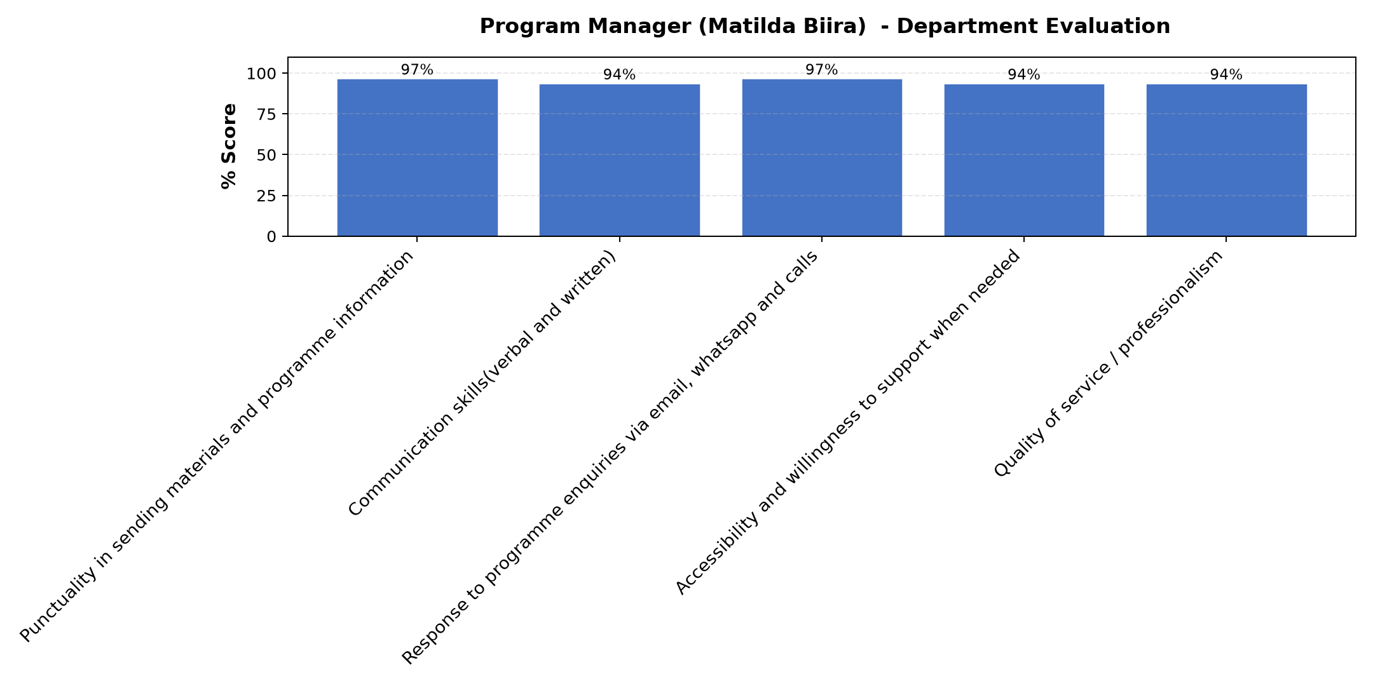

Comments & Feedback
- • She is really committed there is nothing we luck with her. May God bless her as serves us without getting tired.
- • Matilda is very patient
- • Great work done
- • The Feedback from the facilitators. They are open, patience and understanding. They allow everyone to share then they give feedback. They also ask questions to confirm if we areat pa.
- • Keep it Strathmore University
- • I thank the faculty for providing us with knowledge and if possible let continuous sessions continue to be considered for they pull us from where we are lost from, they push us from where we are stuck and strengthen us to move forward.
- • Next time if possible some prior training could be done on how to use teams

Day 1 Further Comments

Comments & Feedback
- • Input appreciated
- • I request for the today's slides
- • Network
- • The presentation was good
- • I found difficulties with network today and yet the session was good and important. I think once in while physical sessions are needed because most of the times we miss what is important for us because of poor network.
- • I thank the faculty for sharing and the good preparation.
- • I have a challenge of poor network so in most cases I miss some in put.

Day 2 Further Comments

Comments & Feedback
- • i am encouraged to gain more knowledge for further use.
- • The input has been so good. Thanks to the organisers
- • Thank you
- • Thanks to the organisers
- • enriching input

Day 3 Further Comments

Comments & Feedback
- • I plan to share this knowledge with my sisters handling the enterprise I was handling in Gulu.
- • Superiors need to be informed when one needs to be transferred.
- • Thank you
- • Great information delivered and it is very effective if one is allowed to use the skills on the social interprenourship for 5 years.
- • Thanks for all the technical support received.
- • I thank the faculty for sharing and the advice
- • Thanks to Strathmore University
- • Thanks so much the input was empowering
- • Well explained
- • I suggest that before superiors transfer sisters, they need to confirm with the Strathmore If the responsibility given was accomplished.
- • the sessions were enjoyable and rich in the subject matter.

Overall Evaluation
Evaluation Parameter | (%) Score
Overall program evaluation | 80
Average score | 80

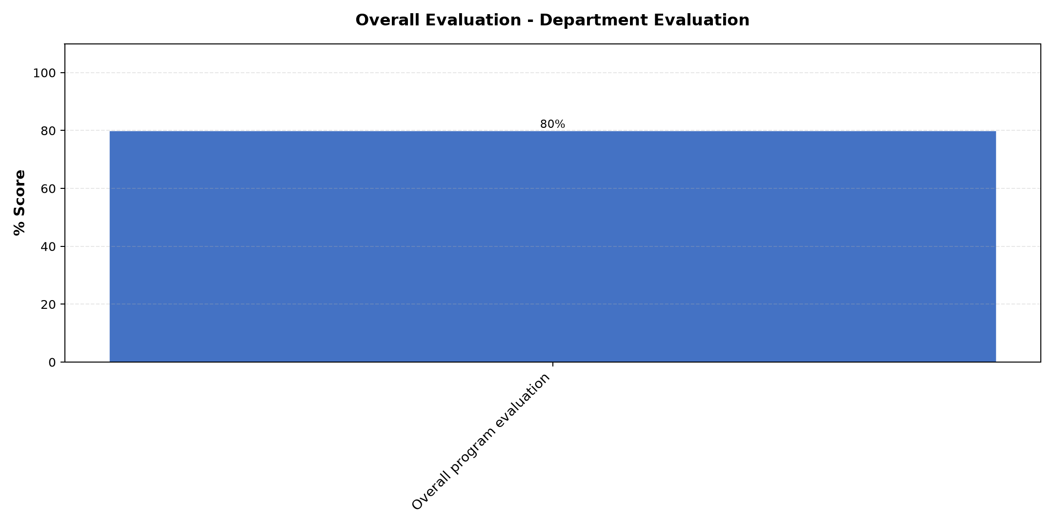

Comments & Feedback
- • Thanks for the tireless support, knowledge and skills imparted me I am very grateful.
- • The follow up lessons have been good to put us right.
- • The information shared is really important and I appreciate Lucy for sharing with us and reminding us our responsibilities.
- • I was impressed with how the information was delivered however sometimes net work was a challenge
- • Thanks a lot for the input

What attracted you to the programme??

Comments & Feedback
- • s that all the facilitators were basing on what we are supposed to do in our different enterprises and we all fit in the class however in different fields.
- • Also the participants sharing without fear whether they still on right truck or not and thank all our facilitators who tried their best to put us right where we had gone a stray
- • Love for mission sustainability
- • At first I was nominated to attend but currently am grateful for the knowledge gained from the training
- • What attracted me was identifying gaps that needs to be closed in our social enterprise and and how to work on them.
- • Sharing
- • Presentation of Dr. Tom when it comes to use the available resources and space
- • The organiser Madam Matilda motivated me

What topic would you recommend being expanded/improved in this programme’s units?

Comments & Feedback
- • Long term and sustainability planning
- • Financial management
- • Enterprise sustainability tactics
- • Business planning
- • Taxation and accounting concepts
- • Preparation for funding

Which areas in this programme did you find most important to your social enterprise?

Comments & Feedback
- • All were important because throughout the course I have been evaluating our enterprise, I was able find out out strength and where our weaknesses are.
- • All was good
- • Financial accountability and proper planning
- • All the areas were important
- • Planning
- • Identifying a long term sustainability
- • Planning for Sustainability

Which teaching methods applied in the course did you enjoy/learn from the most?

Comments & Feedback
- • Questions and sharing
- • Participatory method
- • Class Sharing method
- • Discussion method because it allowed both the students and facilitator to learn from each other. It also made we students to be alert so that we understand the feed back from the facilitator whenever we asked the questions.
- • Discussion
- • Group presentations
- • Social impact measures and planning

